FACEBOOK AD MAIN IMAGE:

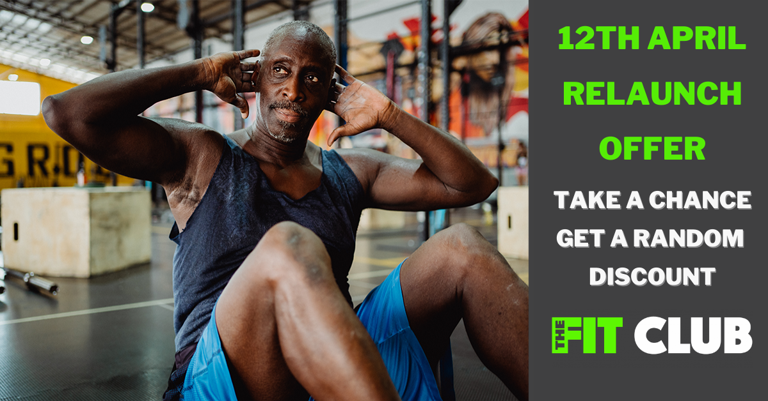

HEADLINE:
Random Discount For The Next 32 Sign Ups

DESCRIPTION:
The next 32 sign ups can get their 12 month gym membership for a huge saving. It all depends on what discount you spin on our discount wheel!

PRIMARY TEXT:
The next 32 members that sign up for the club can get unlimited gym membership for up to a potential discount of....well, you'll have to spin the discount wheel and see!

You can sign up right away and join us in the gym on April 12th and save up to 75% on your first month of gym membership.

We've spent the entire lockdown completely refurbishing every aspect of the club. We've redecorated the entire gym, rebranded our name, updated our look and upgraded our equipment.

At present the gym is following all COVID procedures, to allow all our members to have adequate space to enjoy their workout while social distancing.

Our classes have been restarted, so you can start attending any of our classes right away. Your membership is completely unlimited, so you have over 70 classes to attend, which is all included with your membership.

And you get all of that from just £19.99 a month, with an even bigger saving if you win a big discount on our discount wheel.

Plus you also save on our £20 join fee, so you save even more by joining up right now.

You get unlimited access to all of our facilities, gym, weights area, sauna, steam room and over 70 classes a month... and all at the best price for a gym in Redditch.

Signing up for this amazing deal has never been easier, but we're only offering it to the next 32 gym sign ups.

Simply click the link below and you'll be taken to our sign up page.

There you just need to enter your first name and email. We'll then give you an exclusive promo code (we'll also email it so you don't lose it) so that you can sign up straight away.

You'll get that great price for as long as you're with us and you can sign up for 12 months straight away, to guarantee that amazing price for a full year and get your year off to a great start.

It's time to get fit and healthy, and change your life with The Fit Club Redditch, the best value gym in Redditch.

